V 0
@ Delete v | Archive 0 Report v Eo Mov | e to v | < | v | Qi Share to | Teams | Zoom
Re: AEM/CRM | @ Summarise this email

asha angadi<ashaangadi4@gmail.com> To: O Anjani Vankayala (People Prime)
Cc: ® Vamshi Kalyan Bucha (People Prime)
0 f-.._ Reply Reply all Forward

Fri 10/07/202611:08

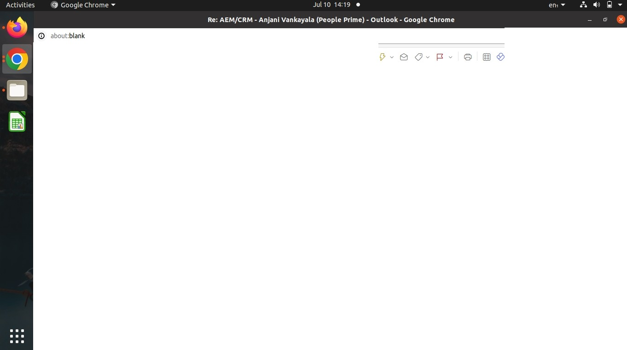
ci'J Resume Asha-1.docx _{V}
28KB

Start reply with: ( Received, thank you. ] ( Got it, thanks! ] ( Thank you!

Hi Anjani,

Thanks for reaching out.As we discussed over the phone, I am sharing my updated resume for your reference. Please find the attached resume and let me know if you need any further details.

Thanks & Regards Asha

On Fri, Jul 10, 2026, 10:29 AM Anjani Vankayala (People Prime) <anjani@P.eOP.le-P.rime.com> wrote: Hi Asha,

I hope you are doing well. My Name is ANJANI, and I am HR Recruiter . As discussed on call, we currently have an opening for the posttion Of [Senior AEM / CMS Specialist] with one of our clients [Virtusa J for ( Hyderabad, Bengaluru, Pune, Chennai, Gurugram ]. Send Me Your Relieving Leners In Your Current And Previous Companies.

This Job opportunity is for C2H, and you will be on the payroll of people prime world wide and working at our client Company. (Virtusa J for [ Hyderabad, Bengaluru, Pune, Mumbai, Chennai, Gurugram].

Please find below detailed Job description, CTC, Work location, Mode of work, Notice Period for your reference and acknowledge the same to proceed further. Post confirmation we will process your candidature.

